hacking.community — Social Media Brand Kit
Always styled lowercase: hacking.community — "hacking" in white, ".community" in accent cyan.
Base: Global / remote-first · Website: https://hacking.community

1. Brand Story

Long (~300 words) — for About pages & press
Every hiring pipeline in security has the same bug: it filters for people who write good résumés, not people who find good vulnerabilities. hacking.community exists to patch it.
We're the home for ethical hackers — one platform that takes you from your first terminal command to your first job offer, and proves every step along the way.
It starts in the Academy: ten structured domains covering the full offensive-security landscape, built for people learning from zero and practitioners filling gaps. No fluff, no filler — guided paths written hacker-to-hacker.
Then you prove it. Hosted vulnerable labs you can attack legally, live CTF events with real leaderboards, and hosted bug-bounty programs where the findings — and the payouts — are real. Our sibling-lab live verification means your skills aren't self-reported; they're demonstrated under observation, on infrastructure we control. Nobody can fake a shell.
Finally, you get hired — without leaving the platform. hacking.community ships the first native interview suite built for security hiring: scheduling, live video interviews, in-call technical tooling, and structured offer workflows. Recruiters and companies don't read claims about your skills; they see the evidence — solved labs, CTF placements, verified findings, all attached to your profile.
For hackers, that means the work you put in is the résumé. For companies, it means every candidate in the pipeline arrives pre-verified, with proof instead of promises.
We're global and remote-first, because talent is. Whether you're grinding your first lab in a bedroom in Lagos, capturing flags from a dorm in Berlin, or hiring a red team from São Paulo — the path is the same:
learn > prove > get hired.
That's not our tagline. That's the product.

Short (~50 words)
hacking.community is the home for ethical hackers: a 10-domain academy, hosted labs, live CTFs, and real bug bounties — plus the first native interview suite built for security hiring. Your solved labs and verified findings become your résumé. learn > prove > get hired.

One-liner
The home for ethical hackers — where verified skills, not résumés, get you hired. learn > prove > get hired.

2. Platform Bios (copy-paste ready)

X / Twitter (≤160 chars)
the home for ethical hackers. academy, hosted labs, live CTFs, real bounties — and hiring built on proof, not promises. learn > prove > get hired

Instagram (≤150 chars, line-broken)
the home for ethical hackers
academy · labs · ctfs · bounties
learn > prove > get hired
↓ start free

LinkedIn tagline (≤120 chars)
The home for ethical hackers — training, verified skills, and the first native interview suite for security hiring.

LinkedIn About section
hacking.community is where ethical hackers learn, prove their skills, and get hired — on one platform.
For hackers: a 10-domain academy, hosted vulnerable labs, live CTF events, and hosted bug-bounty programs. Every solved lab, flag, and verified finding builds a profile that works like a résumé — except nobody can fake it. Our sibling-lab live verification demonstrates skills under observation, on infrastructure we control.
For recruiters and companies: a pipeline of pre-verified security talent and the first native interview suite built for security hiring — scheduling, live video interviews, in-call technical tooling, and structured offer workflows, end to end.
Global and remote-first.
learn > prove > get hired — https://hacking.community

TikTok (≤80 chars)
the home for ethical hackers. learn > prove > get hired.

YouTube channel description
hacking.community — the home for ethical hackers.
Learn offensive security across a 10-domain academy. Prove it in hosted labs, live CTFs, and real bug-bounty programs. Get hired through the first native interview suite built for security hiring — where your verified skills are the résumé.
On this channel: lab walkthroughs, CTF recaps, hiring insights, and platform updates. Written and recorded hacker-to-hacker — plain English, no hype.
Start free: https://hacking.community
learn > prove > get hired

Facebook short description
The home for ethical hackers. Learn in a 10-domain academy, prove your skills in labs, CTFs, and bounties, and get hired on verified proof — not résumés. learn > prove > get hired.

3. Handle Suggestions
Priority | Handle | Notes
Preferred | @hack__community | Double underscore — confirmed by founder
Fallback 1 | @hackingcommunity | Cleanest full-name match
Fallback 2 | @hackingdotcommunity | Spells the domain explicitly
Use the same handle on every platform where available; list the active handle in every bio's link line.

4. Brand Foundations
Element | Value
Name | hacking.community (always lowercase; ".community" always in cyan #00f0ff)
Tagline | learn > prove > get hired
Positioning | The home for ethical hackers — training, verified proof of skill, and native security hiring in one platform
Differentiator | Sibling-lab live verification + the first native interview suite for security hiring: proof > promises
Primary accent | #00f0ff (cyan)
Secondary accent | #ffff00 (yellow — sparingly, for emphasis)
Background | #0b0f19 (dark terminal navy)
Text | #f8fafc (headlines) / #e2e8f0 (body) / #94a3b8 (muted)
Headline font | Chivo (bold/black)
Body & code font | JetBrains Mono / IBM Plex Mono
Visual style | Flat, minimal, thin-line, terminal/hacker aesthetic. Subtle scanlines OK.
Banned visuals | Purple gradients, 3D renders, stock people photos, emoji-as-icons
Audience | Ethical hackers (learners → pros) + security recruiters/companies, global & remote-first

Voice — Do / Don't
Do
- Write hacker-to-hacker: plain English, short sentences, technically precise
- Use terminal idioms naturally ($, >, --flags, lowercase)
- Show receipts: numbers, leaderboards, real findings, member wins
- Respect the reader's intelligence — explain, never dumb down
- Keep lowercase styling in casual posts; sentence case is fine on LinkedIn
Don't
- No hype words: "revolutionary", "game-changing", "10x", "unleash"
- No fear-mongering or "hackers are criminals" framing — we are the good guys
- Never mention unreleased features, competitor names, or pricing in graphics
- No emoji walls; one symbol max per line, only if it earns its place
- Never gatekeep — beginners are welcome, and it should read that way

5. Five Key Messages (rotate across content)
- Proof > promises. Your solved labs, CTF placements, and verified findings are the résumé — nobody can fake a shell.
- One path, one platform. Academy to labs to CTFs to bounties to a job offer — learn > prove > get hired, without leaving.
- Verification you can trust. Sibling-lab live verification demonstrates skill under observation, on infrastructure we control.
- Hiring built for security. The first native interview suite for security hiring: scheduling, live video, in-call tooling, offers.
- Global by default. Remote-first, worldwide — talent has no timezone.

6. Hashtag Sets
Core (brand + category) — use on almost every post:
#hackingcommunity #ethicalhacking #cybersecurity #infosec #bugbounty
Reach (high-volume discovery):
#hacking #CTF #pentesting #redteam #websecurity #appsec #cybersecuritytraining
Audience-intent (career & hiring):
#cybersecurityjobs #infosecjobs #learntohack #cybersecuritycareer #hiring
Per-platform usage:
Platform | Count | Mix
Instagram | 8–12 | 3 core + 4 reach + 3 intent
TikTok | 3–5 | 2 core + 2 reach + 1 intent
X / Twitter | 0–2 | 1 core max — hashtags hurt reach on X; prefer plain keywords
LinkedIn | 3–5 | 2 core + 2 intent + 1 reach
YouTube | 3 (in description) | 2 core + 1 reach
Facebook | 0–2 | 1 core if any

7. Content Pillars & Posting Mix
# | Pillar | What it is | Share
1 | learn | Bite-size technique explainers, academy domain spotlights, "from zero" threads | 30%
2 | prove | Lab walkthroughs (post-retire), CTF recaps, leaderboard moments, first-bloods | 25%
3 | community receipts | Member wins, "just got hired" stories, verified-finding highlights | 20%
4 | hiring insights | For recruiters/companies: why proof beats résumés, pipeline data, interview-suite demos | 15%
5 | behind the terminal | Product updates, changelog highlights, build-in-public notes | 10%
Weekly cadence:
Platform | Frequency | Best-fit pillars
X / Twitter | 5–7 posts/wk (1/day) | learn, prove, receipts
LinkedIn | 3 posts/wk | hiring insights, receipts, learn
Instagram | 3–4 posts/wk (+ stories) | prove, receipts, behind the terminal
TikTok | 2–3 videos/wk | learn (60-sec explainers), prove
YouTube | 1 video/wk | prove (walkthroughs), learn
Facebook | 2 posts/wk | receipts, hiring insights (cross-post from LinkedIn)

8. Pinned Post & Launch Captions

Pinned post (X / all platforms, adapt line breaks)
$ whoami
hacking.community — the home for ethical hackers.
> learn: 10-domain academy, built for zero-to-pro
> prove: hosted labs, live CTFs, real bug bounties
> get hired: the first native interview suite for security hiring
your solved labs are your résumé. nobody can fake a shell.
start free → hacking.community

Launch caption 1 — pairs with `launch_announcement_1024x1024.png`
$ status --live
the home for ethical hackers is live.
one platform: a 10-domain academy, hosted labs, live CTFs, real bug bounties — and hiring that runs on proof, not promises.
learn > prove > get hired.
start free → hacking.community
#hackingcommunity #ethicalhacking #cybersecurity #infosec #bugbounty

Launch caption 2 — pairs with `launch_how_it_works_1024x1024.png`
how it works — no magic, just a pipeline:
01 / learn — a 10-domain academy that takes you from zero, guided the whole way
02 / prove — hosted labs, live CTFs, and real bounties. every flag goes on your profile
03 / get hired — recruiters see verified proof, then interview you natively on-platform
the work is the résumé.
hacking.community
#ethicalhacking #CTF #pentesting #learntohack #cybersecuritycareer

Launch caption 3 — pairs with `launch_proof_over_promises_1024x1024.png`
$ diff resume proof
résumés say "proficient in web exploitation."
proof says: 47 labs solved, 3 CTF podiums, 2 verified critical findings.
we built hacking.community because the second one should get you hired.
verified skills. real labs. real hires.
proof > promises → hacking.community
#cybersecurityjobs #infosec #bugbounty #hiring #hackingcommunity

9. Asset Index
Filename | Platform | Dimensions
avatar_1024x1024.png | All platforms — profile picture | 1024×1024
x_header_1500x500.png | X / Twitter header | 1500×500
linkedin_banner_1584x396.png | LinkedIn company banner | 1584×396
facebook_cover_820x312.png | Facebook page cover | 820×312
youtube_channel_art_2560x1440.png | YouTube channel art (safe area 1546×423 centered) | 2560×1440
highlight_academy_1024x1024.png | Instagram highlight — Academy | 1024×1024
highlight_labs_1024x1024.png | Instagram highlight — Labs | 1024×1024
highlight_ctfs_1024x1024.png | Instagram highlight — CTFs | 1024×1024
highlight_bounties_1024x1024.png | Instagram highlight — Bounties | 1024×1024
highlight_hiring_1024x1024.png | Instagram highlight — Hiring | 1024×1024
launch_announcement_1024x1024.png | Launch post (a) — announcement | 1024×1024
launch_how_it_works_1024x1024.png | Launch post (b) — 3-step infographic | 1024×1024
launch_proof_over_promises_1024x1024.png | Launch post (c) — value/slogan | 1024×1024
BRAND_KIT.md | This document | —
BRAND_KIT.docx | Word version with embedded images | —

Embedded Assets
Profile avatar — all platforms (1024×1024)
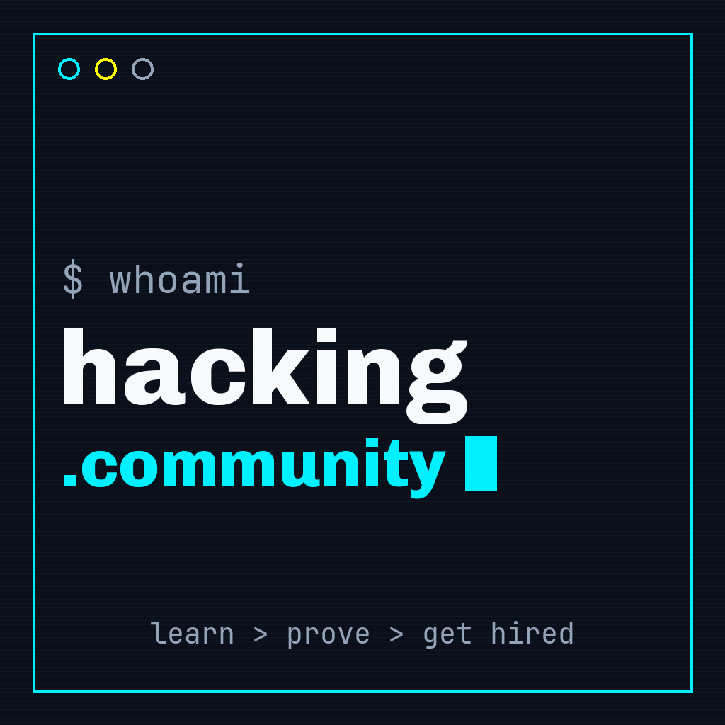
X / Twitter header (1500×500)
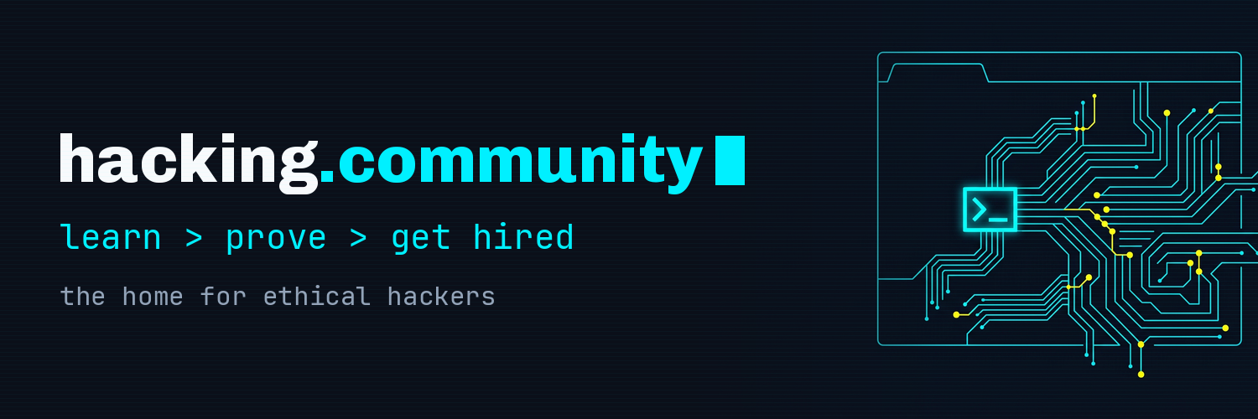
LinkedIn banner (1584×396)
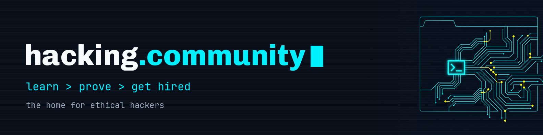
Facebook cover (820×312)
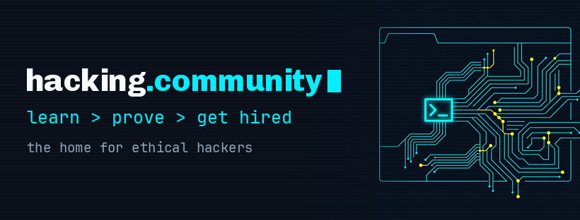
YouTube channel art (2560×1440, safe area 1546×423)
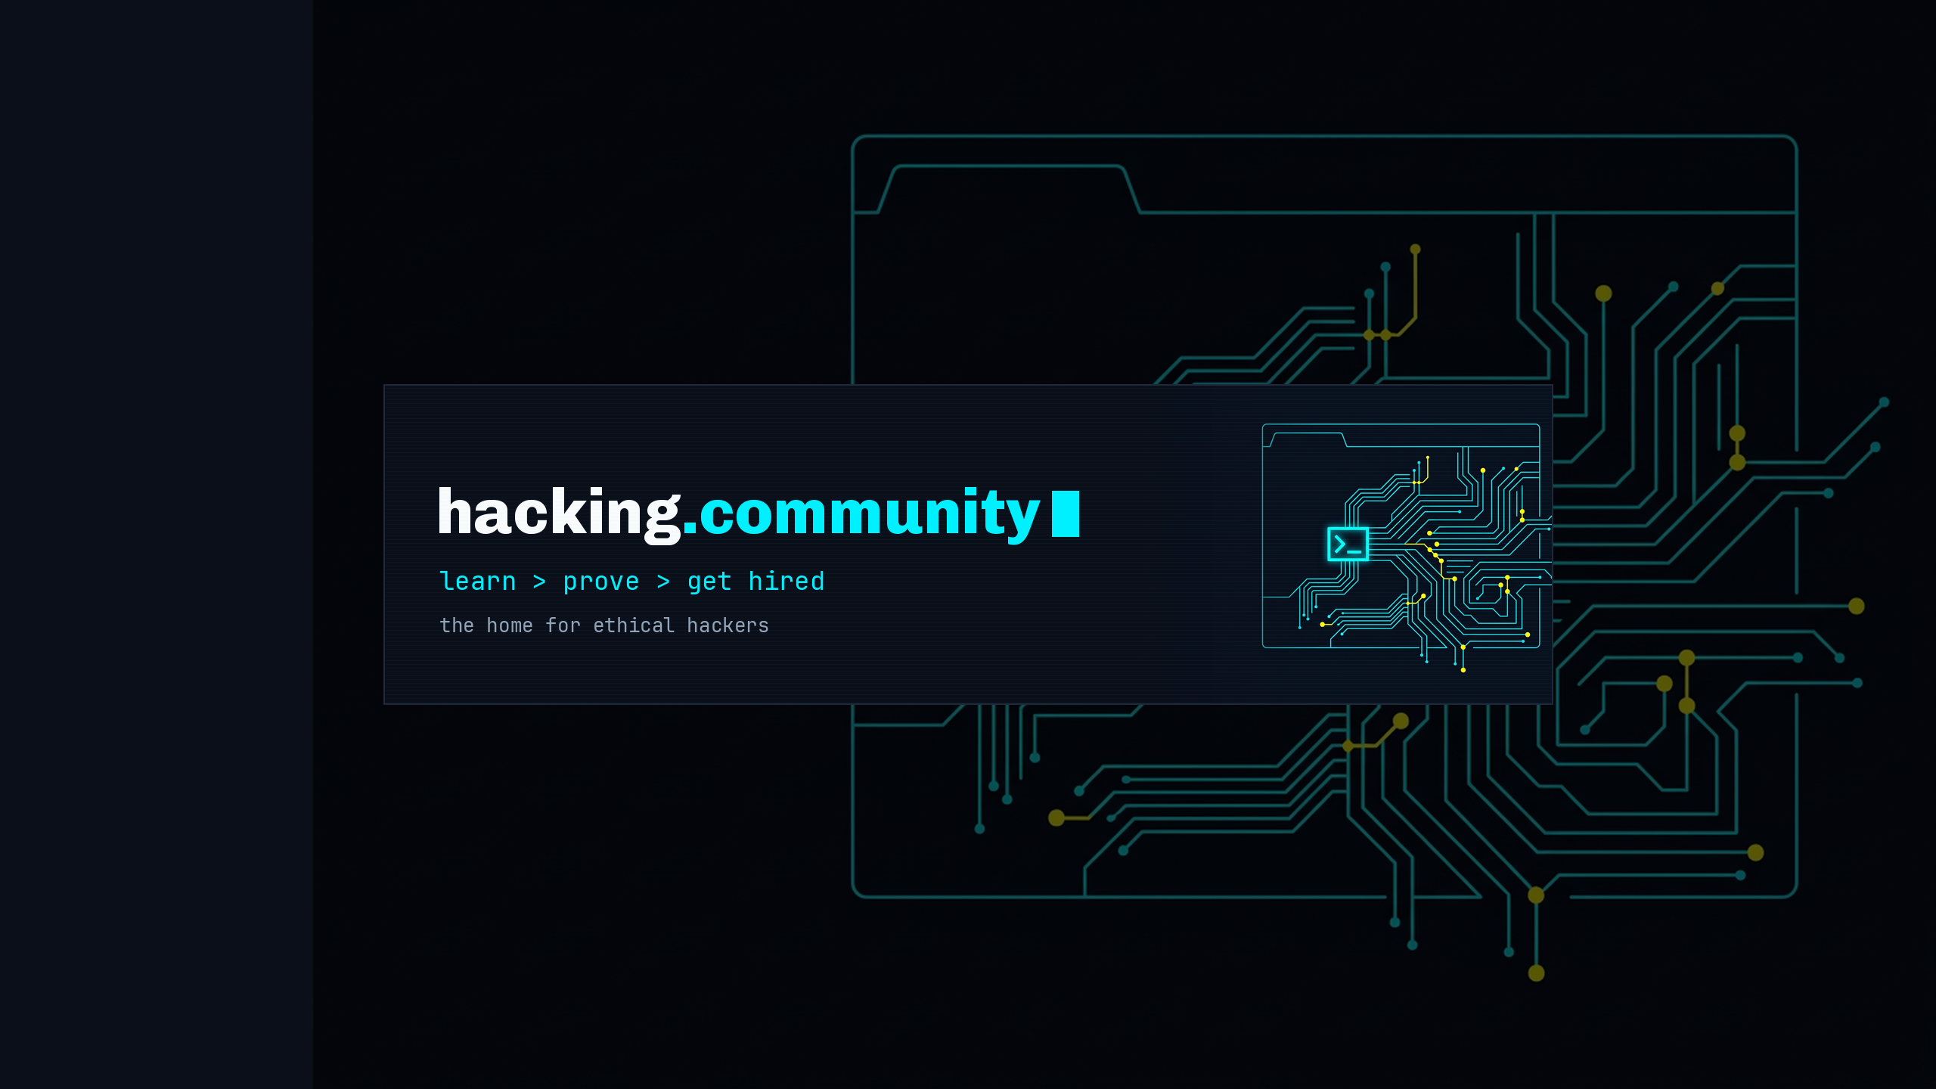
IG highlight — Academy

IG highlight — Labs

IG highlight — CTFs

IG highlight — Bounties

IG highlight — Hiring

Launch post (a) — announcement
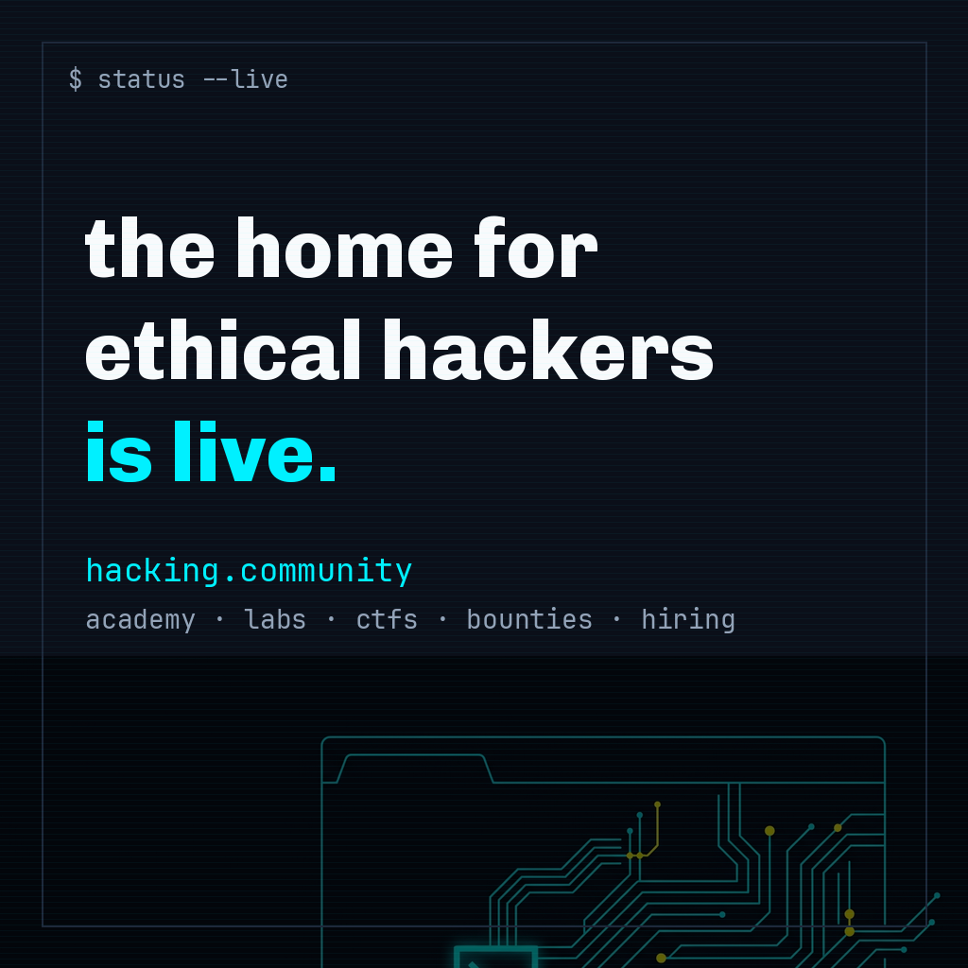
Launch post (b) — how it works
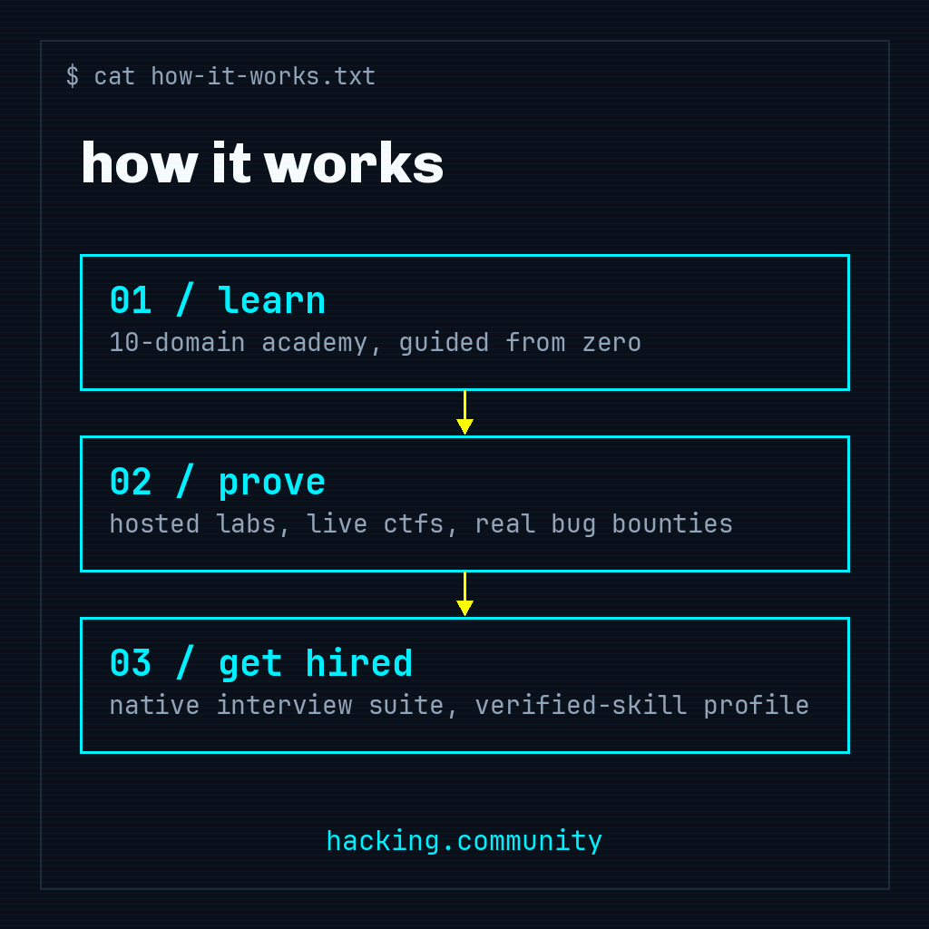
Launch post (c) — proof > promises
